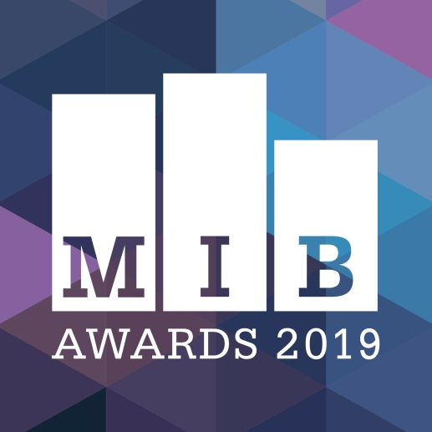
Merseyside Independent Business Awards
2019

Best Start Up Business
(2 Years or under)
BUSINESS NAME
CONTACT NAME
JOB TITLE
EMAIL
TEL
ADDRESS
NO OF EMPLOYEES
SOCIAL MEDIA HANDLES
BUSINESS WEBSITE ADDRESS
BUSINESS TYPE  (highlight as appropriate) | Sole Trader  Partnership  Limited liability company (LTD)  Limited liability partnership (LLP)  Other (please state):
COMPANY REG NUMBER
(If applicable)

Category guidelines

Eligible businesses include: any Merseyside independent business which has been trading for two years or less as of June 01 2019.
If you have any queries regarding eligibility, please contact us on the email below.

Businesses entering must have headquarters based in Merseyside, Liverpool City Region (Liverpool, Wirral, Knowsley, St Helens, Sefton, Halton).

Businesses entering must be fully independent, free from outside control and be privately owned.

Supporting evidence, such as testimonials, photographs, business accounts information is encouraged. This must be no more than three sides of A4, and is to be emailed in PDF format along with completed entry form.
- Judges will score each question out of five points, based on answer quality and clarity

The Merseyside Independent Business Awards takes place on Thursday, October 10 at Rum Warehouse, Titanic Hotel.

The full shortlist will be announced around a month prior to this.

All information and supporting evidence will be treated in the strictest confidence –information will be shared with MIB judges only.

Deadline for entry form submission is 5pm on Friday, August 30 2019

Entries made after this date will not be submitted to judges.

Please submit your completed form & supporting evidence to info@mibawards.co.uk
If you have any queries, please email us on the above address
SMALL PRINT: This form will be treated with the utmost confidentiality. It will be seen by judges and not by any third parties. Following the awards, your form will be securely destroyed.

Q1 – Tell us when your business was established, and what you do.  (300 words max) | Judge use only
Suggested consideration: Does the business provide a unique product to the market? Or has it developed a new approach to delivering services to gain cut-through in an established sector? | /5

Q2 – Tell us about your background prior to launching the business – and why did you establish it?  (300 words max) | Judge use only
Suggested considerations: Who are the people behind the products? Is there a dynamic leadership team or is there one shining light guiding the firm into new experiences?  What path led them to this place?  Where did the spark of creativity come from?  What were the owners of the business planning to do before they veered towards this calling? Or was this the big plan all along, years in the making? | /5

Q3 – What have been your greatest challenges and successes to date?  (300 words max) | Judge use only
Every new enterprise has bumps in the road – how did the business navigate those and did it actually turn out to be a blessing in disguise? Has there been a pivotal breakthrough moment that offers positive signs for the future? | /5

Q4 – What are your aspirations for the business over the next two years, and what makes you stand out from others in your field?  (300 words max) | Judge use only
Are there plans to grow client numbers, hire new staff, expand the footprint of the business or target new sectors? If you could fast forward to 2021, what would success look like? | /5
Judge use only  Overall score | /20

